

**Financial Brains**

**Requirements Specification Document**

**Issue Date: 16-05-2015**

**Version History:**

|  |  |  |  |
| --- | --- | --- | --- |
| **Version No.** | **Date** | **Description** | **Modified By** |
| 1.0 | 16-05-2015 |  | Mohamed Usama |

**Change Requests:**

The following table summarizes the changes to the system since first baseline:

|  |  |  |  |  |  |
| --- | --- | --- | --- | --- | --- |
| **Change Request ID** | **Target Module** | **Amendment Description** | **Affected Sections (Use case, paragraph or figure number)** | **Date** | **A/M/D** |
|  |  |  |  |  |  |

\***A** – ADDED**, M** – MODIFIED, **D** – DELETED

# Table of Contents

Table of Contents 2

1. Introduction 3

2. Modules 3

2.1 Administration (BACK-END) 3

2.1.1 Users Management 3

2.1.2 Primary Data Management 3

2.1.3 Content Management System 3

2.2 Questions (BACK-END & FRONT-END) 4

2.2.1 Overall View 4

2.2.2 Back-End Role 5

2.2.4 Front-End Role 6

# Introduction

Financial Brains is a website provides online certificates exams and questions to students based on their subscriptions, although it’s a portfolio for our company as in our main website:

<http://www.financial-brains.org/>

# Modules

## Administration (BACK-END)

### Users Management

As system admin I should have access on my back-end users and front-end users.

**Back-end users**:

* **Super Admin** have access to all back-end features.
* **Agents** can only add questions and provide access to students on Subjects.

**Front-end users** (students) **management**:

* I should be able to provide front-end users access on some subjects.
* I should be able to set expiry date for front-end user account other than the default period.  
  *default period is one year from the date of activation
* I should be able to set maximum number of devices that can be used by user.  
  *default devices are 3 per user.

### Primary Data Management

I should be able to manage all my system primary data as (Certificates, Levels, Subjects, Study Sessions, Readings, and Sub Categories)

I should be able to provide some helping data that will be shown to front-end users while answering questions, I would like to have a rich text form to enter data as tables or diagrams.

### Content Management System

I should be able to edit texts shown on my website home page, edit instructors profiles and founders profiles, add offers to be shown on homepage if exists.

## Questions (BACK-END & FRONT-END)

### Overall View

The website should provide the administrator to add questions to the system each according its certificate as shown in Figure 1 - Question Hierarchy:

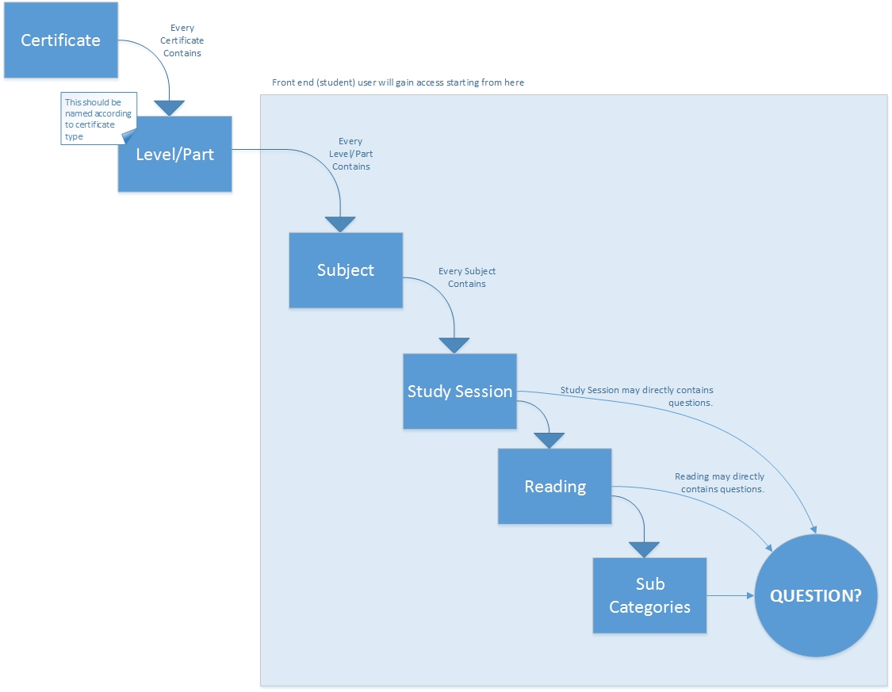

Figure 1 - Question Hierarchy

### Back-End Role

As an admin I shall be able to add questions all according to its hierarchy as shown in Figure 1 - Question Hierarchy, every question should have the following Table 1 - Question Details.

Table 1 - Question Details

|  |  |  |
| --- | --- | --- |
| Field | Type | Comment |
| Information | Rich Text (with only adding tables , headlines and underlines) | System should handle the case that every information piece may be used in multiple questions. |
| Question | Text |  |
| Options (Answers) | Multiple Entries (Text) |  |
| Right Answer | Select one of options |  |
| Justification | Text (Large) |  |
| Expected Answer Duration | Number |  |
| Weight | Number |  |
| Notes | Text |  |
| Related Study Session, Reading, or Sub Category | ID | This will be previously selected as the user will navigate to the Study Session, Reading, or Sub Category to add a Question. |
| Question Pool | Selection | Advanced Questions, Intermediate Questions or Basic Questions |

### Front-End Role

As a student I should be able to access the questions I have privilege on (based on the Subject provided to me by system administrator).

I should be able to select questions to practice as the following:

Select based on:

* Subject
* Study Session
* Reading
* Or Select Questions Individually

I also should have some options after selecting questions as the following.

1. Number of Questions Limit (Number)
2. Limit Question Pool (Multiple Selection)
   1. Advanced Questions
   2. Intermediate Questions
   3. Basic Questions
3. Show Score As You Go (Yes/No)
4. Display Answer & Explanation After Each Question (Yes/No)

While answering questions I should be able to access some help tables (submitted previously by admin) and it would be good to have some links to online calculators.

After finishing my questions I should be provided by a report.